Lab Report

Your Information
Your Name: Joshua Zimmerman-Gibson
Assignment Title: Use Basic AI Techniques

Screenshots
1.2 Load the dataset
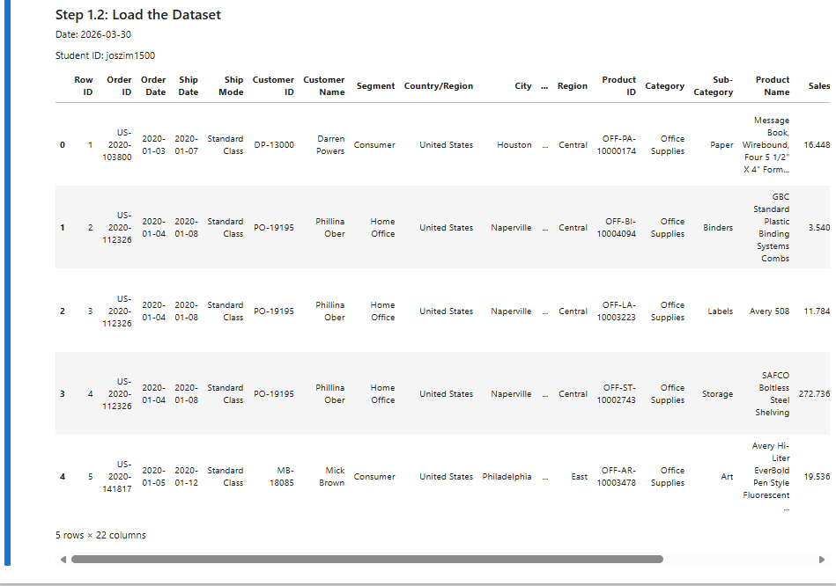
1.3 Data cleaning
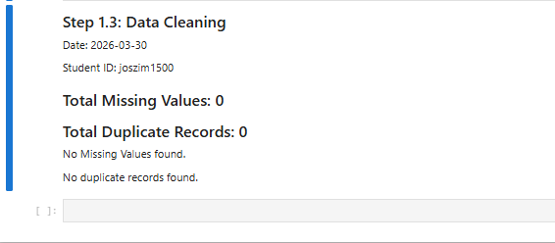
1.4 Feature Encoding
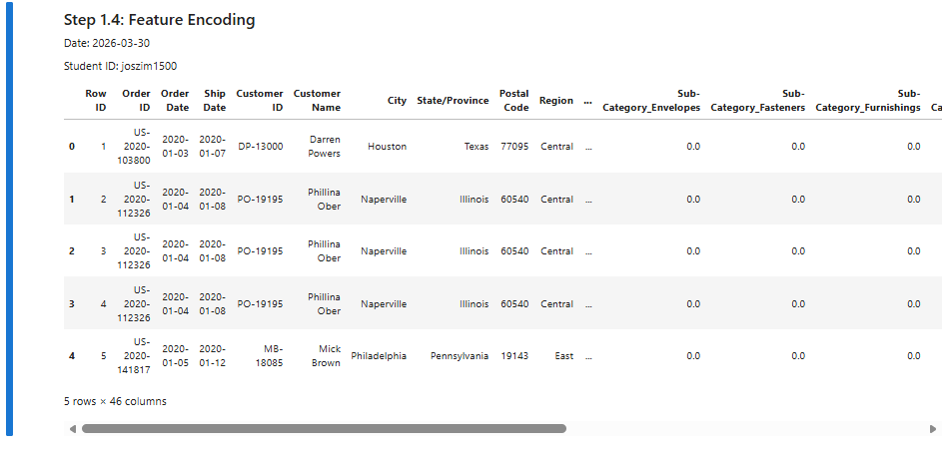
2.1 Text analysis with NLP
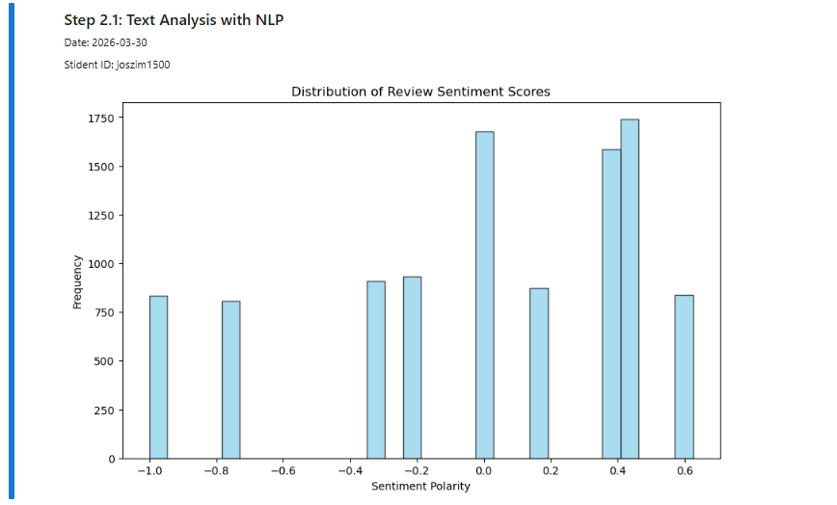
2.2 Detailed Analysis of Selected Sentiment Scores
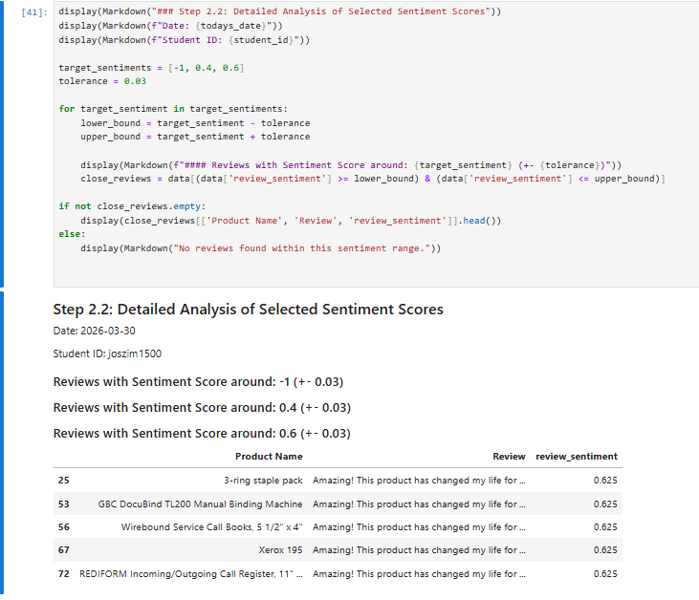
2.3 Preparing Data for neural Network Modeling
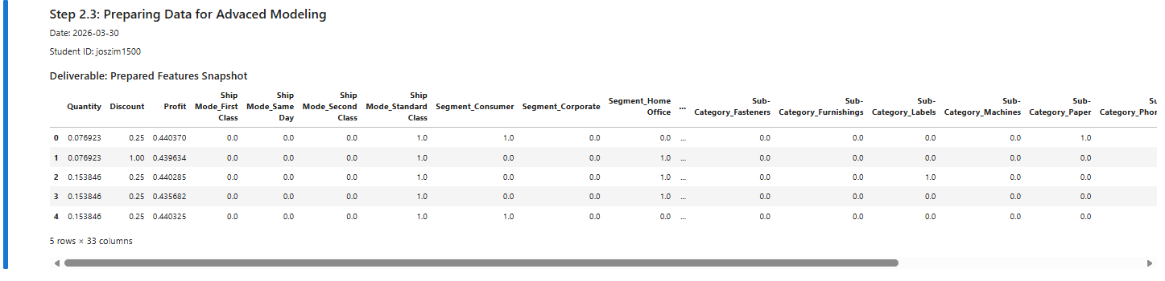
2.4 Construct and train a neural Network Model to Predict Target variable using TensorFlow and Keras
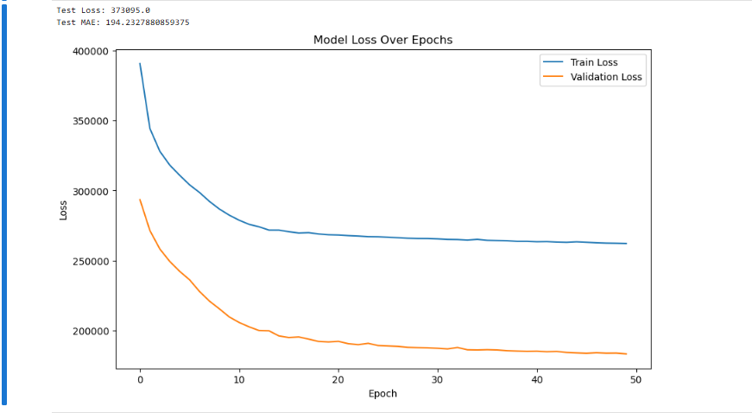
2.5 Enhance the Neural Network Model
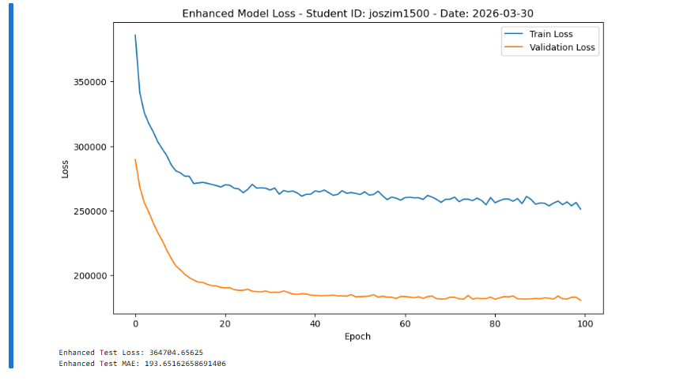
3.1 Interpreting Sentiment Analysis Results
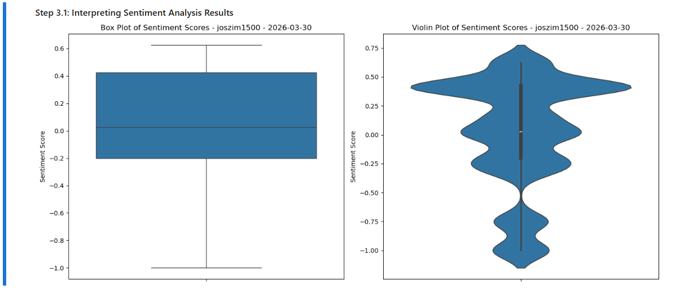
3.2 Business Insights from Model Predictions on known Data
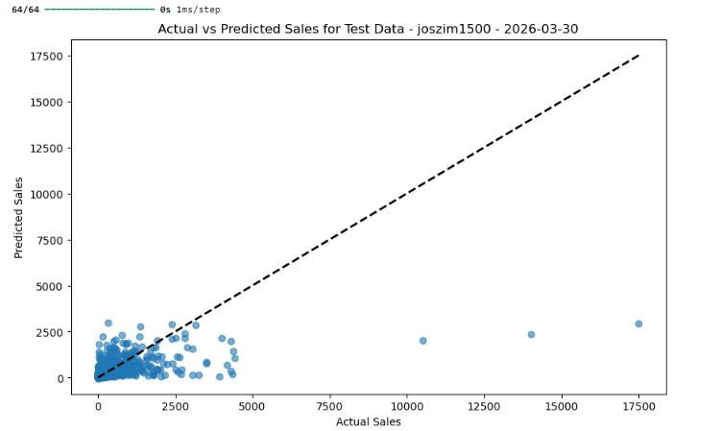
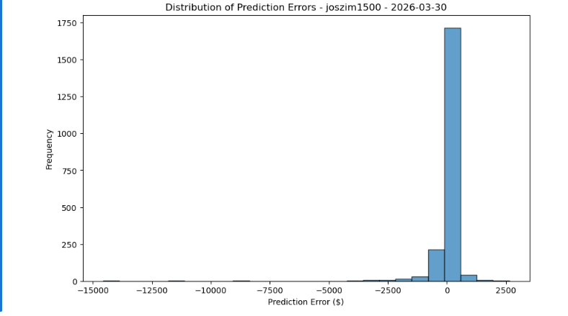

Questions
- What does a high Mean Squared Error (MSE) indicate about the model's performance, and how would you address this issue to improve the model?
A high MSE means your model’s predictions are far from the real values. Basically, the model is not doing a good job.
To improve it, you can try things like:
- Cleaning the data better
- Adding or removing features
- Using more training data
- Changing the model (more layers, different activation functions)
- Tuning parameters like learning rate or number of epochs
Think of MSE like a “distance score” — the bigger it is, the worse the model is guessing.

- When interpreting a box plot and a violin plot of sentiment scores, what does the presence of a wider section in the violin plot indicate, and how does it complement the information provided by the box plot?
A wider part of a violin plot means more data points are in that range. It shows where the scores are most common.
A box plot shows:
- Median
- Quartiles
- Outliers
But a violin plot shows the shape of the whole distribution, not just summary stats.
Together:
- Box plot = quick summary
- Violin plot = deeper look at how the data is spread
They work well as a pair.

- How can the interpretation of a scatter plot comparing actual sales to predicted sales inform business strategy, especially when considering the alignment of points with the identity line?
If the points are close to the identity line (the diagonal line), it means:
- The model predicts sales accurately
- The business can trust the model’s predictions
If the points are far from the line:
- The model is off
- Predictions may not be reliable for planning
This helps businesses decide whether they can use the model for things like:
- Forecasting sales
- Managing inventory
- Setting budgets
The closer the points are to the line, the more useful the model is.

